MATHEMATICS—2005 (Set II —Outside Delhi )
Except for the following questions, all the remaining questions have been asked in Set 1.
Q. 1. If 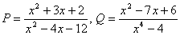and
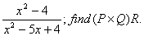
Ans( x+1/x-4)
Q. 2. Find the sum of all multiples of 9 lying between 300 and 700.
Ans(21,978)
Q. 6. The 4th term of an Arithmetic Progression is zero. Prove that its 25th term is triple its 11 th term.
Q. 11. Solve the following system of equations graphically:
2x - 5y + 4 = 0
2x + y - 8 = 0
Find the points where the lines meet the y-axis.
Ans:B (0,0-8); C(0,8)
Q. 12. A two digit number is such that the product of its digits is 20. If 9 is added to the number, the digits interchange their places. Find the number.
Ans:(45)
Q. 20. A bag contains 5 red, 8 white and 7 black balls. A ball is drawn at random from the bag. Find the probability that the drawn ball is
(i) red or white
(ii) not black
(iii) neither white nor black.
Ans:(13/20; 13/20; ¼)
Q. 21. If a line is drawn parallel to one side of a triangle, prove that the other two sides are divided in the same ratio.
Use the above to prove the following:
In the given figure DE II AC and DC II AP.
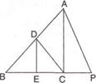
Prove that 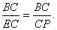
Ans:(Rs.1,254)

